**HOSPITAL MANAGEMENT SYSTEM**

***A Project Report submitted to***

***Bishop Heber College (Autonomous), Tiruchirappalli***

***affiliated to Bharathidasan University, Tiruchirappalli – 620024***

***in partial fulfillment of the requirements for the award of the degree of***

# Bachelor of Vocation in Information Technology

*By*

**S. MOHANRAJ**

**(REGISTER NO: 225915135)**

*Under the guidance of*

Mr. F. JABEZ SAMUEL MCA ,M. Phil



**Department of Information Technology**

**Bishop Heber College(Autonomous)**

*(Nationally Re-accredited with ‘A’ Grade by NAAC with a CGPA of 3.58 out of 4)*

*(Recognized by UGC as “College of Excellence”)*

*Tiruchirappalli 620 017*

**NOVEMBER 2022**

**Department of Information Technology**



**Bishop Heber College(Autonomous)**

**Tiruchirappalli-620 017,Tamilnadu,India**

**Phone No:0431-277 0136**

## CERTIFICATE

This Viva-Voce examination for the candidate  **S.MOHANRAJ**

### **(Reg No:225915135)** was held on_________________________

Signature of HOD

Examiner

1.

2.

**Mr.F. JABEZ SAMUEL MCA., M. Phil**



Assistant Professor,

Department of Information Technology,

Bishop Heber College (Autonomous),

Tiruchirapalli-620 017

**Date:**

## CERTIFICATE

This is to certify that the project work entitled **“ HOSPITAL MANAGEMENT SYSTEM”** is a bonafide work done under my supervision by **S.MOHANRAJ**  and submitted to Bishop Heber College (Autonomous), Tiruchirappalli – 620 017 in partial fulfillment of the requirements for the award of the degree of Bachelor of Vocation in Information Technology during the odd semester of the academic year (2022-2025).

**Signature of the Guide**

## DECLARATION

I hereby declare that the work presented in this project work report is the original work done by me under the guidance of **Mr.F.JABEZSAMUEL, MCA, M.phil.,**Assistant Professor of Information Technology, Bishop Heber College (Autonomous),Tiruchirapalli-620 017and has not been included in any other project work submitted for any other degree.

Name of the Candidate :S.MOHANRAJ

Register Number :225915135

Semester :FIRST

Academic Year :2022 – 2023

Course Code :U21ITPJ1

**Signature of the Candidate**

**ACKNOWLEDGEMENTS**

Words are beyond our expression as I remain with grateful heart at the thershold of presenting our consolidated project report joyfully acknowledging the divine providence that I experience throughout my project.

First of foremost, I thank **THE ALMIGHTY GOD** for granting abundant grace. Good health and knowledge to do this Project.

I express my sincere gratitude to Dr**.D.PAUL DHAYABARAN, M.Sc., M.Phil., PGDCA., Ph.D.,** Principal., Bishop Heber College (Autonomous), Tiruchirapalli for providing the opportunity to pursue this programme.

I am highly indebted to thanks **Dr. J. JOHN RAYBIN JOSE, M.sc.,MCA, M.Phill, PGDCA ,Ph.D, SET.**  Associate professor and Head , Department of Information Dechnology , Bishop Heber College (Autonomous), Trichy for providing all the support and facilities to do this project work.

I wish to place on record my gratitude to **Mr. F. JABEZ SAMUEL, MCA, M.phil.,** Assistant Professor in Department of Information Technology, Bishop Heber College (Autonomous), Tiruchirapalli for grant me permission to pursue carry on with this project and guiding me to complete the project successfully.

I thank all the Staff members of the Department of Information Technology for their contribution to complete this project work successfully.

I record my deep sense of gratitude to my beloved parents and my friends for their encouragement and moral support extended during the period of my project.

**S.MOHANRAJ**

**SYNOPSIS**

Our project **Hospital Management system** includes registration of patients, storing their details into the system.

Our software has the facility to give a unique id for every patient and stores the details of every patient.User can search availability of a patient using the id. The Hospital Management

It is accessible either by an administrator or receptionist. Only they can add data into the database. The data can be retrieved easily. The interface is very user-friendly. The data are well protected for personal use and makes the data processing very fast.

It is having mainly two modules. One is at Administration.The Application maintains authentication in order to access the application. Administrator task includes managing doctors information, patient’s information. To achieve this aim a database was designed admin can access. The complaints which are given by user will be referred by authorities.

**CONTENTS**

|  |  |  |
| --- | --- | --- |
| **S. NO.** | **TITLE** | **PAGE NO.** |
| **1** | **INTRODUCTION** | 1 |
| **2** | **SYSTEM STUDY** | 2 |
| 2.1. PROJECT DESCRIPTION | 2 |
| 2.1.1. EXISTING SYSTEM | 2 |
| 2.1.2. PROPOSED SYSTEM | 3 |
| 2.2REQUIREMENT ANALYSIS | 4 |
| 2.2.1 HARDWARE REQUIREMENT | 4 |
| 2.2.2 SOFTWARE REQURIMENTS | 5 |
| **3.** | **SYSTEM DESIGN** | 7 |
| 3.1. LOGICAL DESIGN | 7 |
| 3.2 PROGRAM DESIGN | 8 |
| 3.3.MODULE DESIGN | 8 |
| **4.** | **SYSTEM DEVELOPMENT** | 10 |
| 4.1. PROGRAM DEVELOPMENT | 10 |
| **5.** | **SYSTEM TESTING** | 23 |
| 5.1. UNIT TESTING | 23 |
| 5.2.INTEGRATION TESTING | 23 |
| **6.** | **SYSTEM IMPLEMENTATION** | 24 |
| 6.1 SYSTEM DEMONSTRATION | 24 |
| **7.** | **CONCLUSION** | 28 |
|  | **BIBLIOGRAPHY** | 29 |

# **1. INTRODUCTION**

Hospital Management System is a system enabling hospitals to manage information and data related to all aspects of healthcare – processes, providers, patients, and more, which in turn ensures that processes are completed swiftly and effectively.

The greatly evolved since then – with the ability to integrate with the existing facilities, technologies, software, and systems of a hospital. Today, patients can begin the process of healthcare in the palm of their hand – the mobile devices and apps make this possible. This process then moves to the healthcare providers and hospitals.

# **2. SYSTEM STUDY**

System analysis is a process of gathering the facts concerning the system breaking them into elements and relationship between elements; it provides a framework for visualizing the organizational and environmental factors that operate on a system. The quality of work performed by a machine is usually uniform, neat and more reliable when compared to doing the same operations manually.

## 2.1.Project Description

Our project Hospital Management system includes **registration of patients, storing their details into the system**. Our software has the facility to give a unique id for every patient and stores the details of every patient and the staff automatically. This software application helps administrator to update data in step by step process. Admin will login using for authentication purpose.

### **2.1.1. Existing System**

In existing system is very slow and inefficient. Report generation is also not an easy task in the current situation. Also if the report is generated then calculations are done manually that leads to more errors. There is a lot of manual work involved in current system and mistake in one detail can lead to wrong generation of page. No proper collection of requirements leads a huge problem for this system. This system is to enhance manual work and also more energy is wasted to includes registration of patients, storing their details into the system.

Current system is manual so all the records are maintained manually. So the includes registration of patients, storing their details into the system of students cannot be determined if updating is not done.

* Time Consuming
* Less Efficient

### 2.1.2.Proposed System.

The proposed system “HOSPITAL MANAGEMENT SYSTEM” application is developed for the theatre to simplify the registration of patients, storing their details into the system. It facilitates to access the registration of patients, storing their details into the system.

**Advantages:**

• The system automates the manual procedure of managing hospital activities.

• Doctors can view their patients’ treatment records and details easily.

• It even generates an instant bill.

• The system is convenient and flexible to be used.

• It saves their time, efforts, money and resources.

**Disadvantages:**

• Requires large database.

• The admin has to manually keep updating the information by entering the details in the system.

• Need Internet connection.

# **2.2.REQUIRMENT ANALYSIS**

Recruitments analysis involves frequent communication with system users to determine specific feature expectations, resolution of conflict or ambiguity in recruitments as demanded by the various users or groups of users, avoidance of feature creep and documentation of all aspects of the project development process final from start to finish. Energy should be directed towards ensuring that the system or product conforms to client needs rather than attempting to user expectations to fit the recruitments. Recruitments analysis is a team effort that demands a combination of hardware, software and human factors engineering as well as skills in dealing with people.

## 2.2.1.Hardware Requirement

The hardware specification of the Laptop computer system available for developing the project is given below.

|  |  |
| --- | --- |
| Processor | AMD PRO |
| Hard disk capacity | 500 GB |
| Internal memory capacity | 4 GB |
| Keyboard | STANDARD KEYBOARD |
| Cpu clock | 1.08 GHz |
| System Type | 64 bit Operating System |

## 2.2.2.Software Requirement

A Software requirement specification (SRS) is a complete description of the behavior or the system to be developed. It includes a set of use cases that describes all the interaction the users will have with the software.

|  |  |
| --- | --- |
| Operating system | Windows10 |
| Software application | Dev c++ |
| Programming language | C programming |

## Operating system

An operating system is software that communicates with the hardware and allows other to run. 1t comprises the system software, and other utilities. The Operating system used as platform to develop this project in windows 7 Ultimate and later. It is a multi-user operating system.

## Programming language

**Front end (dev c++)**

Android (stylized as android) Dev-C++ is a free integrated development environment (IDE) for programming in C/C++. Dev-C++ is developed by Bloodshed software. It is shipped with the open source MinGW compiler. MinGW uses GCC,the GNU g++ compiler collection. With Dev-C++ you can write Windows or console-based C/C++ programs easily, you can even create installer for your application. Dev-C++ is hosted on Sourceforge. Current available version is 4.9.9.2(i.e Version 5 Beta). There is no news of recent updates for this IDE. Also Dev-C++ runs solely on windows, linux port no longer exists. Update: There is a development team that has taken DevC++ IDE added few extra features like support for multiple compilers and Wxwidgets RAD port.This IDE is renamed as wxDev-C++.

**Functional Requirement**

This specification is used to specify the requirements for the initial implementation of the system and update the system in future. The software requirement specification bridges the gap between client/user and the system developer. This is the document that describes the user needs accurately.

**Performance Requirement**

This document will provide general description of the project product perspective, and overview of requirement, general constraint and user view of the product while using. In additional will also provide the specific requirement and functional needs for this project such as interface, functional and performance requirements. The purpose of this software requirement specification is to properly document the requirement of the user necessary in order to build this application.

# **3.SYSTEM DESIGN**

System design is the process of defining the architecture, components, modules, interfaces, and data for a system to satisfy specified requirements. System design could be seen as the application of system theory to product development.

**3.1. LOGICAL DESIGN**

Logical design is an abstract concept in computer programming by which programmers arrange data in a series of logical relationships known as attributes or entities.

**3.2 PROGRAM DESIGN**

Program design is the activity of progressing from a specification of some required program to a description of the program itself. Most phase models of the software life cycle recognize program design ns one of the phase. The input to this phase specification of what the program is required to do. During the phase the design decisions are made as to how the program will meet these requirements, and the output of the phase is a description of the program in some form that provides a suitable basis for subsequent implementation.

**3.3 MODULE DESCRIPTION**

Hospital Management is the add record and delete record to all details in The Event management system.

**Modules:**

Implementation is the stage of the project when the theoretical design is turned out into a working System. Thus, it can be considered to be the most critical stage in achieving a successful new system and in giving the user, confidence that the new system will work and be effective.

The implementation stage involves careful planning, investigation of the existing system and its constraints on implementation, designing of methods to achieve changeover and evaluation of changeover methods.

* Add Information

This segment is used for adding new patient

* View Inormation

Viewing the list of patiends added

* Search

Searching the particular added patiend.

* Edit Information.

Editing the information of the patient added.

* Delete Information

To delete the patients information.

* Exit

To exit the program.

# **4.SYSTEM DEVELOPMENT**

The Software Development Life Cycle(SDLC), also referred to as the application development life-cycle, is a term used in system engineering, information system and software engineering to describe a process for planing, creating testing and deploying an information system. The system developments life-cycle concept applies to a range of hardware and software configurations, as a system can be composed of hardware only, software only, or a combination of both.

## 4.1 PROGRAM DEVELOPMENT

#include<stdio.h>

#include<string.h>

struct ad

{

char name[30];

char disease[30];

int cabin,phone,age;

} x[100];

int n,i,j=0,a=0,sum=0,g,flag,num;

void read();

void add();

void view();

void search();

void edit();

void del();

void show();

int main()

{

read();

int c,i,q;

printf("Hospital Management System\n");

int m,n;

while(c!=6)

{

printf("**Enter your choice**\n\n1. Add Information\n2. View Information\n3. Search\n4. Edit Information\n5. Delete Information\n6. Exit\n\nOption=");

scanf("%d",&c);

fflush(stdin);

if(c==1)

{

add();

}

else if(c==2)

{

view();

}

else if(c==3)

{

search();

}

else if(c==4)

{

edit();

}

else if(c==5)

{

del();

}

else if(c==6)

{

add();

return 0;

}

else

{

printf("\n\nInvalid input , try again by using valid inputs");

}

printf("\n\n");

}

}

void add()

{

printf("\n\n");

printf("How many entry do you want to add=\n");

scanf("%d",&n);

sum=n+num;

for(i=num,j=0; i<sum; i++)

{

printf("\n");

fflush(stdin);

printf("Enter patient's Name = ");

gets(x[i].name);

fflush(stdin);

printf("Enter disease = ");

gets(x[i].disease);

fflush(stdin);

printf("Enter the age = ");

scanf("%d",&x[i].age);

fflush(stdin);

printf("Enter cabin no = ");

scanf("%d",&x[i].cabin);

fflush(stdin);

printf("Enter phone number = ");

scanf("%d",&x[i].phone);

fflush(stdin);

printf("\n");

j++;

a++;

num++;

}

}

void view()

{

for(i=0; i<num; i++)

{

printf("\n");

printf("Serial Number=%d\n",i);

printf("Name = ");

puts(x[i].name);

printf("Disease = ");

puts(x[i].disease);

printf("Cabin no = %d\nPhone number =%d\nAge=%d",x[i].cabin,x[i].phone,x[i].age);

printf("\n\n");

}

}

void edit()

{

int q,p;

fflush(stdin);

printf("What do you want to edit ?\n");

printf("Enter your option\n");

printf("1.Name\n2.Disease\n3.Age\n4.Cabin\n5.Phone no.\n");

printf("Option=");

scanf("%d",&q);

if(q<=5)

{

printf("Enter the serial no of that patient= (0 - %d)=",num-1);

scanf("%d",&p);

if(p<num)

{

if(q==1)

{

fflush(stdin);

printf("Enter the new name=");

gets(x[p].name);

}

else if(q==2)

{

fflush(stdin);

printf("Enter the new Disease=");

gets(x[p].disease);

}

else if(q==3)

{

fflush(stdin);

printf("Enter the new Age=");

scanf("%d",&x[p].age);

}

else if(q==4)

{

fflush(stdin);

printf("Enter the new Cabin no=");

scanf("%d",&x[p].cabin);

}

else if(q==5)

{

fflush(stdin);

printf("Enter the new Phone no =");

scanf("%d",&x[p].phone);

}

}

else

{

printf("\n\nInvalid Serial \nTry Again !!\n\n");

}

}

else

{

printf("\n\nInvalid option\nTry Again!!\n\n");

}

}

void search()

{

int s,h,f;

char u[100];

printf("By what do you want to search ?\n");

printf("1.Serial no.\n2.Name\n3.Disease\n4.Cabin no.\n5.Phone no.\n6.Age\n\nOption = ");

scanf("%d",&h);

if(h==1)

{

printf("Enter Serial number of the patient=");

scanf("%d",&s);

if(s<num)

{

printf("\n");

printf("Serial Number=%d\n",s);

printf("Name = ");

puts(x[s].name);

printf("Disease = ");

puts(x[s].disease);

printf("Cabin no = %d\nPhone number = 0%d\nAge = %d",x[s].cabin,x[s].phone,x[s].age);

printf("\n\n");

}

else

printf("\n\nNot Found\n\n");

}

else if(h==2)

{

int f=1;

fflush(stdin);

printf("Enter your name=");

gets(u);

fflush(stdin);

for(g=0; g<num; g++)

{

if(strcmp(u,x[g].name)==0)

{

printf("\n");

printf("Serial Number=%d\n",g);

printf("Name = ");

puts(x[g].name);

printf("Disease = ");

puts(x[g].disease);

printf("Cabin no = %d\nPhone number = 0%d\nAge = %d",x[g].cabin,x[g].phone,x[g].age);

printf("\n\n");

f=0;

}

}

if(f==1)

printf("\nNot Found\n");

}

else if(h==3)

{

int f=1;

fflush(stdin);

printf("Enter Disease = ");

gets(u);

fflush(stdin);

for(g=0; g<num; g++)

{

if(strcmp(u,x[g].disease)==0)

{

printf("\n");

printf("Serial Number=%d\n",g);

printf("Name = ");

puts(x[g].name);

printf("Disease = ");

puts(x[g].disease);

printf("Cabin no = %d\nPhone number = 0%d\nAge = %d",x[g].cabin,x[g].phone,x[g].age);

printf("\n\n");

f=0;

}

}

if(f==1)

printf("\nNot Found\n");

}

else if(h==4)

{

int f=1;

printf("Enter Cabin number = ");

scanf("%d",&f);

for(g=0; g<num; g++)

{

if(f==x[g].cabin)

{

printf("\n");

printf("Serial Number=%d\n",g);

printf("Name = ");

puts(x[g].name);

printf("Disease = ");

puts(x[g].disease);

printf("Cabin no = %d\nPhone number = 0%d\nAge = %d",x[g].cabin,x[g].phone,x[g].age);

printf("\n\n");

f=0;

}

}

if(f==1)

printf("Not Found\n\n");

}

else if(h==5)

{

int f=1;

printf("Enter Phone number = ");

scanf("%d",&f);

for(g=0; g<num; g++)

{

if(f==x[g].phone)

{

printf("\n");

printf("Serial Number=%d\n",g);

printf("Name = ");

puts(x[g].name);

printf("Disease = ");

puts(x[g].disease);

printf("Cabin no = %d\nPhone number = 0%d\nAge =%d",x[g].cabin,x[g].phone,x[g].age);

printf("\n\n");

f=0;

}

}

if(f==1)

printf("Not Found");

}

else if(h==6)

{

int f=1;

printf("Enter Age = ");

scanf("%d",&f);

for(g=0; g<num; g++)

{

if(f==x[g].age)

{

printf("\n");

printf("Serial Number=%d\n",g);

printf("Name = ");

puts(x[g].name);

printf("Disease = ");

puts(x[g].disease);

printf("Cabin no = %d\nPhone number = 0%d\nAge = %d",x[g].cabin,x[g].phone,x[g].age);

printf("\n\n");

f=0;

}

}

if(f==1)

printf("Not Found\n\n");

}

else

printf("\n\nInvalid input\n\n");

}

void del()

{

int f,h;s

printf("Enter the serial number of the patient that you want to delete=");

scanf("%d",&f);

if(f<num)

{

printf("What do you want ?\n");

printf("1.Remove the whole record\n2.Remove Name\n3.Remove Disease\n4.Remove age\n5.Remove Cabin\n6.Remove phone number\nOption = ");

scanf("%d",&h);

if(h==1)

{

while(f<num)

{

strcpy(x[f].name,x[f+1].name);

strcpy(x[f].disease,x[f+1].disease);

x[f].age=x[f+1].age;

x[f].cabin=x[f+1].cabin;

x[f].phone=x[f+1].phone;

f++;

}

num--;

}

else if(h==2)

{

strcpy(x[f].name,"Cleared");

}

else if(h==3)

{

strcpy(x[f].disease,"Cleared");

}

else if(h==4)

{

x[f].age=0;

}

else if(h==5)

{

x[f].cabin=0;

}

else if(h==6)

{

x[f].phone=0;

}

}

else

printf("\n\nInvalid Serial number\n");

}

void read()

{

FILE *fp = fopen("patient.txt","r");

if(fp == NULL)

{

fp = fopen("patient.txt","w");

fclose(fp);

}

num = fread(x, sizeof(struct ad),100, fp);

fclose(fp);

}

void write()

{

FILE *fp = fopen("patient.txt","w");

if(fp == NULL)

{

printf("Error");

}

fwrite(x, sizeof(struct ad),num, fp);

fclose(fp);

}

# **5.SYSTEM TESTING**

System testing is the process of evaluation and software item to detect differences Testing assesses the quality of the product. Software testing is a process that should be done during the development process. In other words, software testing is a verification and validation process.

## 5.1.UNIT TESTING

Unit testing verification efforts on the smallest unit of software design, module. This is known as "Module Testing” After testing every field in the modules, the modules of the project is tested separately. Unit testing focuses verification efforts on the smallest unit of software design and field. While filling the details in the register form certain fields are left as empty and checked.

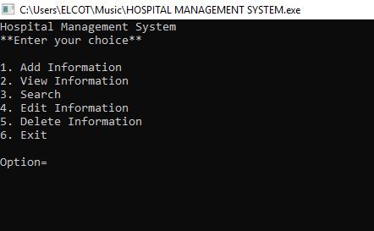

Fig 5.1 Output page.

# **6.SYSTEM IMPLEMENTATION**

System implementation is an important stage of the project where the theoretical design is turned into practical system .the system can be implemented only after through testing is done and if it is found to work according to the specification. The problems encountered are converting files, training users, creating accurate are converting files and verifying printouts for integrity. A post implemented overview measures the system performance against predefined review determines how well the system continues to meet performance specifications. A post implementation review is an evaluation of the system in terms to which the system accomplishes stated objectives and actual project work exceeds initial estimates.

**6.1**.**SYSTEM DEMONSTRATION**



Fig:6.1 ADMIN PAGE

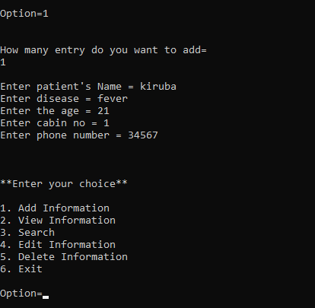

Fig:6.2 ADD INFORMATION

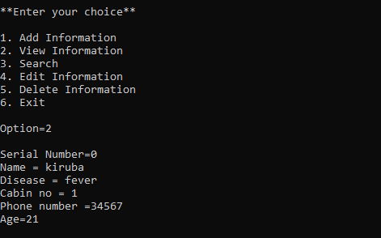

Fig:6.3VIEW INFORMATION

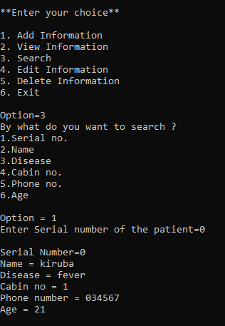

**Fig:6.4SEARCH**

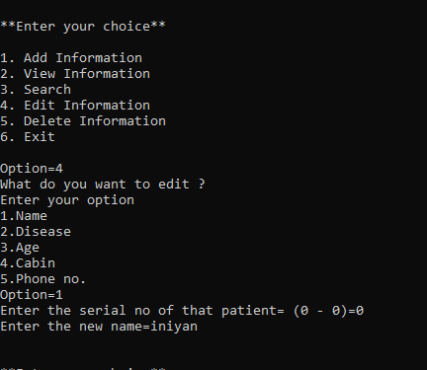

Fig:6.5 EDIT INFORMATION

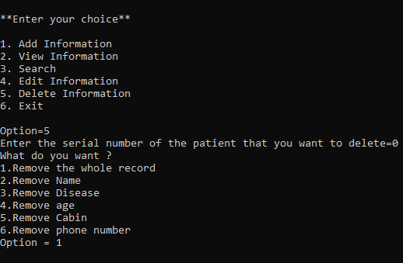

Fig:6.6 DELETE INFORMATION

# **7.CONCLUSION**

The software developed has fulfilled the necessary requirements as required by the user. It is ensured that all the programs are working properly in“HOSPITAL MANAGEMENT SYSTEM”. The system is used to design to operate in a user friendly manner. Proper documentation done from different areas, without difficulty and provides smooth running of all the operations. The system that has been developed in C is to improve more user interactivity. This project avoids errors. The system has achieved the objective of being information system for Auctioning purposes. This project has been implemented and tested.

**BIBLOGRAPHY**

**BOOK REFERENCE:**

1. C Programming Absolute Begginer’s Guide,Greg Perry,b3rd edition,Que Publishing.
2. C.Programming in easy steps, 5th Edition,Mike McGrath,5th edition,In Easy steps Limited
3. C.The Complete Refrence ,Herbert Schildt,4th edition,McGraw Hill Education.

**WEBSITE REFRENCES:**

* 1. <https://www.programiz.com/c-programming>
  2. [https://www.freecodecamp.org/news/what-is-the-c-programminglanguage-beginner-tutorial/](https://www.freecodecamp.org/news/what-is-the-c-programming-language-beginner-tutorial/)
  3. <https://www.\geeksforgeeks.org/c-language-set-1-introduction/>